ASCENDION | UNILEVER AGENTIC SALESFORCE DISCOVERY
Org Compiler Validation: Visit Execution
Prepared by Gowrishankar Palanisamy, Salesforce Solution Architect · 28 October 2026 · For Himant Gupta, Anoop Thomas and leadership
Summary
The Org Compiler finds the right components and gets its facts right. But in the Visit execution module, only 1 of its 7 findings is fully correct, and it misses most of how visits are set up in the org, because that setup is stored as records, not code. Two fixes (reading setup records, and showing which visit model is in use) would close most of the gap.

1. At a glance
The app is reliable at finding components and weak at placing them in the right business process.
Check | Result | Rating
App findings fully correct | 1 of 7 | Weak
App findings partly correct (wrong step or process) | 3 of 7 | Weak
App findings that are not visit execution | 3 of 7 | Weak
Facts checked by the app (record counts, active or inactive) | 2 of 2 correct | Good
Package parts kept apart from custom work | All correct | Good
Custom fields on Visit found | 0 of 1 | Missed
Visit setup stored as records (templates, task definitions) | Not read | Missed
Which visit model the org uses | Not stated | Missed

2. What we compared
We checked one business process, Retail execution: Visit execution, in the app against the same Salesforce org.
Item | Detail
Salesforce org | Ascendion's Consumer Goods (CG) Cloud demo org. CG Cloud package version 262.2, 81 installed packages.
App run | Org Compiler, Discovery explorer, run DISC-202610221736 of 22 Oct 2026, org "CG Cloud"
What the app shows | 3 steps: start the visit, perform visit tasks, capture a signature. 7 components, all under "Start the visit", marked as a technical-debt candidate.
How we checked the org | We pulled the module's setup from the org with Salesforce developer tools (a list of components, a download of their definitions, and record counts). Then we read what each flow really does: the records it starts from, reads, creates and updates.
Date of check | 28 October 2026

A standard part comes with Salesforce or the CG Cloud package. A custom part was built in this org. Setup stored as records means settings kept as data rows (for example visit templates), not as code or metadata.
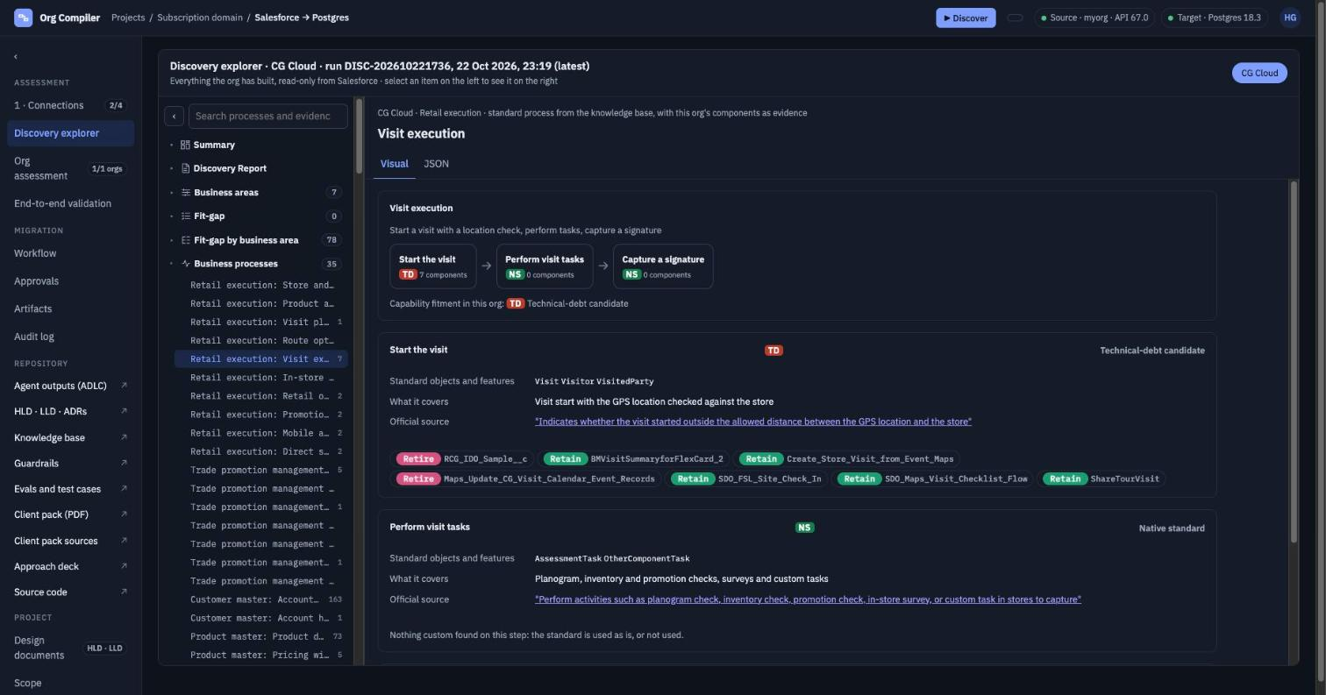
Figure 1. The Visit execution view in the Org Compiler (run of 22 Oct 2026)
3. Item by item: the app's 7 findings
Only ShareTourVisit is a correct finding in the correct step. The other 6 sit in the wrong step, or are not visit execution at all.
# | Component | App verdict | What it really does in the org | Our result
1 | ShareTourVisit (flow) | Retain | Runs when a visit is saved and shares the visit with the person responsible for it. | Correct
2 | BMVisitSummaryforFlexCard_2 (flow) | Retain | An AI prompt flow that reads visits and visit jobs to write a visit summary. It runs after the visit, not at the start. | Partly correct: wrong step
3 | Create_Store_Visit_from_Event_Maps (flow) | Retain | Creates a visit when an event is saved in Salesforce Maps. This is visit planning. | Partly correct: belongs to "Visit planning"
4 | SDO_Maps_Visit_Checklist_Flow (flow) | Retain | A Maps screen that creates tasks on the store's account as a home-made visit checklist. | Partly correct: belongs to "Perform visit tasks". Should be reviewed against the standard visit tasks, not just kept.
5 | SDO_FSL_Site_Check_In (flow) | Retain | A Field Service flow for work orders and service appointments. It is not part of CG Cloud. | Wrong: matched on the words "Check In" in its name
6 | Maps_Update_CG_Visit_Calendar_Event_Records (flow) | Retire (inactive) | A one-time setup flow for Maps calendar events. It is a draft and not active. | Fact right, module wrong
7 | RCG_IDO_Sample__c (custom object) | Retire (no records) | A sample object for key account management (company, contact, feedback). 0 records, no link to visits. | Fact right, module wrong

4. What the app missed
The biggest gap is that the app does not read setup stored as records. In CG Cloud, this is where most of the visit process is defined.
Missed item | What the org shows | Why it matters
Visit task setup stored as records | Core Salesforce: 14 action plan templates, 12 assessment task definitions, 52 assessment indicators, 31 retail store KPIs. CG Cloud package: 21 visit templates, 7 job templates, 106 job definition lists, 167 job definition templates. | The app says "Perform visit tasks: nothing custom, the standard is used as is or not used". In fact, this is where the org defines what a rep does in the store.
Which visit model is in use | The org has two models side by side. Core Salesforce: 0 assessment tasks and 0 signature tasks. CG Cloud package: 108 signatures, 355 job lists. 52 visits in total. | The app maps every step to core Salesforce objects that are hardly used here. It never says the work runs through the CG Cloud package objects.
Custom field Maps_Visit_Duplication__c on Visit | The only custom field on the Visit object. The app's search does not find it. | A fit-gap must list every custom field on the main object of the process.

5. What the app did well
The base the app builds on is sound, so the fixes below build on what is already there.
- Package parts are not counted as custom. The 42 CG Cloud fields on Visit, its 4 record types, 3 validation rules and 3 package triggers are all treated as standard. This is correct.
- Its facts are right. The sample object really has 0 records, and the Maps setup flow really is inactive.
- It skips a near miss. It left out a Field Service signature flow (SDO_SFS_SendForCustomerSignature) under "Capture a signature", which is correct.
- Each step quotes Salesforce. The standard for every step is backed by a quote from the Salesforce Retail Execution guide.
- It is easy to check. The search box, the visual view and the JSON view made this review quick.

6. Recommendations for the Org Compiler
Fixes 1 and 2 matter most. Without them, the fit-gap for any CG Cloud process will be incomplete.
Priority | Change | What it fixes | Example from this check
1 | Read setup stored as records, and count it per step: action plan templates, assessment task definitions and indicators, store KPIs, and the CG Cloud visit, job and tour templates. | The "nothing custom" result on steps that are set up as data | "Perform visit tasks" shows 0 components, but the org has hundreds of task setup records.
2 | Show which model is in use (core Salesforce or the CG Cloud package), based on record counts for each object. | Steps mapped to objects the org does not use | Signatures: 108 in the CG Cloud object, 0 in the core object
3 | Place each flow by the objects it works on: the record it starts from, reads, creates and updates. Do not place it by its name. | Wrong process and wrong step | SDO_FSL_Site_Check_In was placed by the words "Check In", but it works on work orders
4 | Include custom fields on standard objects such as Visit, Account and Retail Store. | Custom work that is not reported | Maps_Visit_Duplication__c on Visit is not found
5 | Tag parts from other products (Field Service, Maps, demo tools) as "other product", and keep them out of CG Cloud processes. | Clutter in the fit-gap | 3 of the 7 findings are from Field Service, Maps setup or a sample object
6 | Give a reason for the technical-debt label: which parts caused it and why. | Labels that are hard to trust | "Start the visit" is marked as technical debt, but only 1 flow and 1 field there are real custom work on visits

7. Next steps
- Himant to review the 6 recommendations and plan fixes 1 and 2 first.
- Run the Org Compiler again on the demo org after the fixes, and repeat this check on Visit execution.
- Repeat the check on one more module. Trade promotion management (TPM) is the hardest test, but it needs the TPM licence from Salesforce first. Until then, Retail order capture is an option.

